1. The need for Strategy Design is to obtain _______________ results at minimum cost.

A. Betters

B. Unambiguous

C. Efficient

D. Simple

Ans: B. Unambiguous

2. The need for Strategy Design is to obtain _________________ with limited number of experiments.

A. Interaction effects

B. Uncontrollable variable

C. Crucial Factors

D. Noise factors

Ans: C. Crucial Factors

3. The term Replication is a systematic duplication of series of experiments runs. It provides the means of measuring precision by calculating the _________________.

A. Experimental error

B. Noise factors

C. Treatment level

D. Mean (or) Average.

Ans: A. Experimental error

4. An industrial experiments is performed to capture the changes in input variables, so that the output variables is always near to the desired nominal value. This phenomena is known as _____________.

A. Process characterization

B. Process optimization

C. Robust design

D. Process Control

Ans: D. Process Control.

5. Which of the following method fails to consider any possible interaction between the factors?

A. Full Factorial Design

B. One Factor at a Time

C. Best-Guess Approach

D. Strategic Design

Ans: B. One Factor at a Time

6. In a study on defective parts, if 40 defectives are required and suppose the past defective percent in a process is 8%. Then, the total sample size required (all trials/ runs) shall be ____.

A. 400

B. 500

C. 320

D. 200

Ans: B. 500

7. A techniques used to ______________ of an experiment by breaking the experiment into homogeneous segments in order to control noise factors.

A. increase the precision

B. decrease the variability

C. increase the accuracy

D. minimize the cost

Ans: A. increase the precision

8. An experiment was conducted with a factor called dosage and with three levels. The experiment was conducted for 7 runs for each levels. What is the degrees of freedom within the factors?

A. 18

B. 20

C. 2

D. 21

Ans: A. 18

9. In an interactions graph, there is no interaction between the process parameters, which means, the lines in the interaction plot would be ___________.

A. Non-parallel

B. Parallel

C. Almost parallel

D. crosses.

Ans: B. Parallel

10. In Synergistic interaction, the combined effect of two factors is ____________ the individual factors on the response.

A. Lesser than

B. Equal to

C. Greater than

D. Double than

Ans: C. Greater than

11. When higher level of one independent variable enhances the effect of another independent variable. This phenomenon is called ______________.

A. Synergistic Interaction

B. Antagonistic Interaction

C. Process optimization

D. Robust design

Ans: A. Synergistic Interaction

12. When main effect is non-significant and interaction is significant. In this situation the two independent variables tend to reverse each other’s effect. This phenomenon is called ______________.

A. Synergistic Interaction

B. Antagonistic Interaction

C. Process optimization

D. Robust design

Ans: B. Antagonistic Interaction

13. With respect to interaction graph, the greater the degree of departure from being parallel, the ____________ the interaction effect.

A. Weaker

B. Stronger

C. Equal

D. Non-significant

Ans: B. Stronger

14. Consider the data given from an experiment below and find out the interaction effect between A and B.

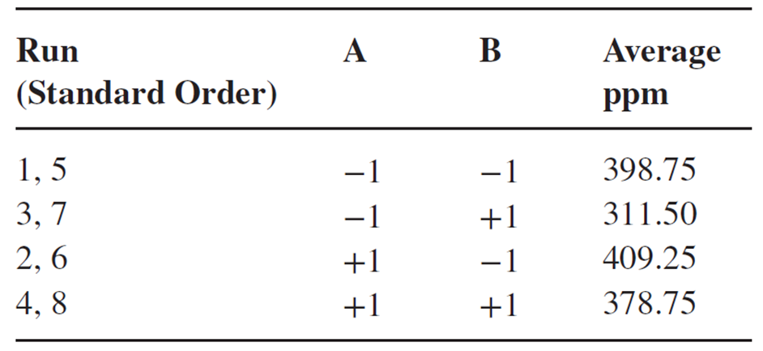

A. 67.25 ppm

B. 10.5 ppm

C. 28.375 ppm

D. 100. 25 ppm

Ans: C. 28.375 ppm